1. Flu Problem
2. Influence Diagrams

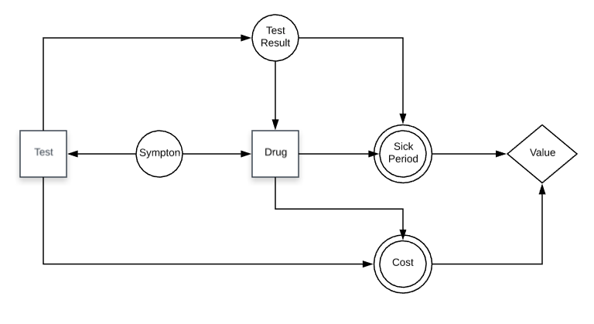

1. Decision Tree

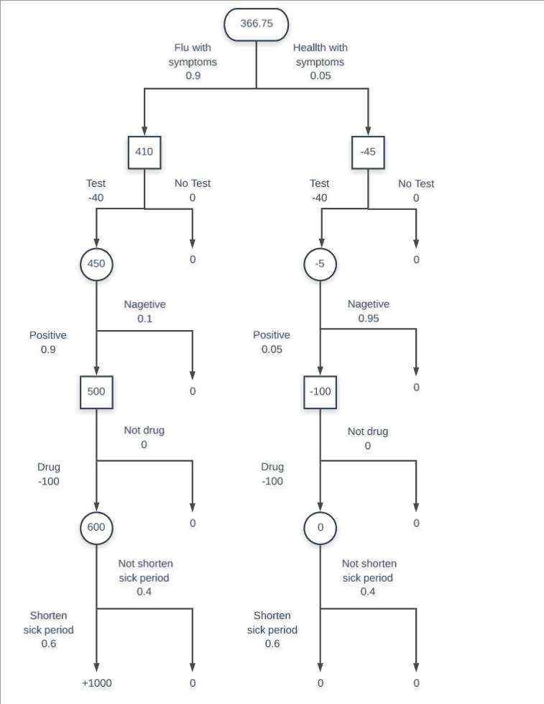

1. Summary

Influence Diagrams: With the given material, there are two decision nodes within this process, whether test or not and whether drug or not. Besides, the end node should be set as the value considering not only the final reward, which is represented by the length of the sickness period, but also the total cost. So the rest factors, including symptoms and results of the test, are regarded as the chances nodes. At last, the connections among each node are drawn according to the materials as well, which will be described in follow.

Decision Tree: First of all, the doctor only needs to consider those patients with exhibiting symptoms. Then the doctor should decide whether conduct a test or not to further diagnosis. At the same time, the patient has to take a cost from the test. With different accuracy in the test results, the second decision for this doctor is whether administer a drug, which finally leads to different cost and different period of sickness. Following this clue, the decision tree can be drawn so that the value of each node/state can be calculated with backward propagation along the tree. The principle of the backward propagation is shown as followed:

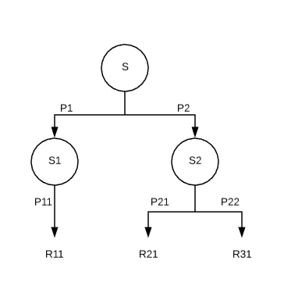

$$S=P1×S1 +P2×S2=P1×\left(P11×R11\right) +P2×(P21×R21+P22×R22)$$

1. Influence Diagrams in HIV Problem
2. To calculate the the expected utility for the treatment option with known HIV status

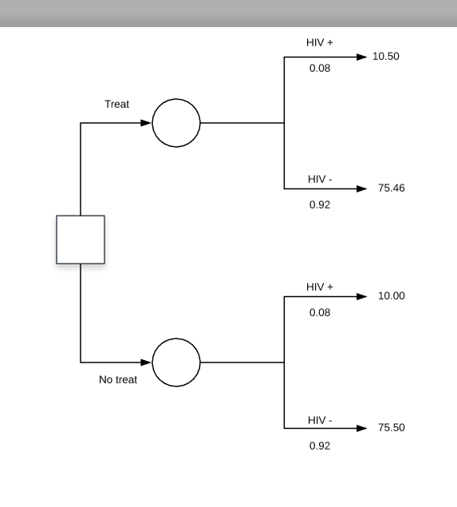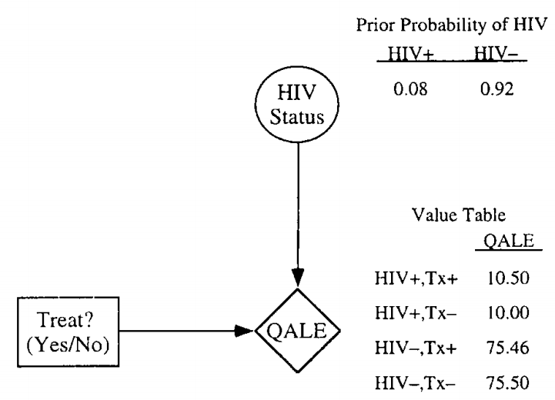

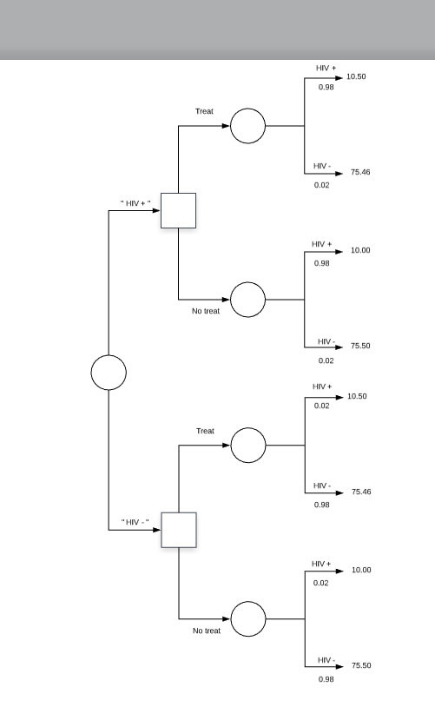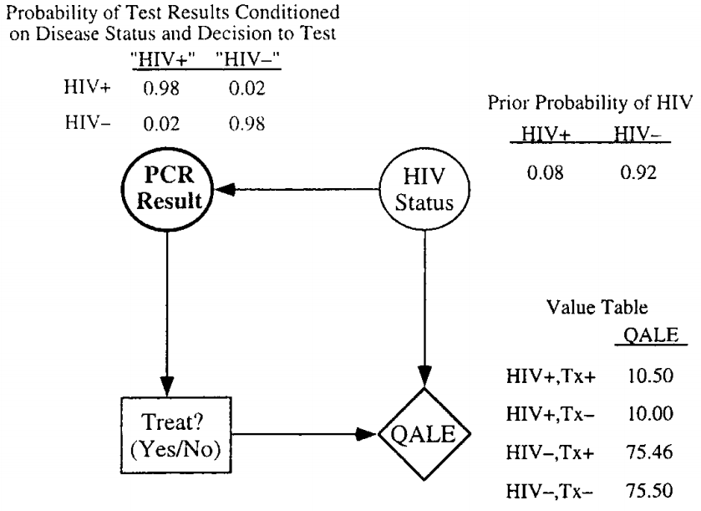

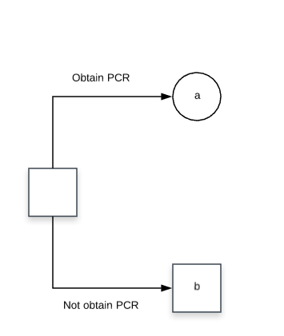 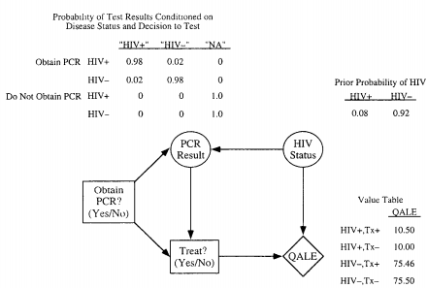

1. Summary

As the followed equantion shown, the expected utility for the treatment option Tx+ can be calculated.

$$EU\left[T_{x}+\right]=p\left[HIV+\right]U\left[HIV+, T_{x}+\right]+p\left[HIV-\right]U\left[HIV-, T_{x}+\right]$$

$$EU\left[T_{x}+\right]=0.08×10.50+0.92×75.46=70.2632$$

Same as the expected utility for the non-treatment option Tx-.

$$EU\left[T_{x}-\right]=p\left[HIV+\right]U\left[HIV+, T_{x}-\right]+p\left[HIV-\right]U\left[HIV-, T_{x}-\right]$$

$$EU\left[T_{x}-\right]=0.08×10.50+0.92×75.46=70.2632$$

According to the results, it can be implied that, given a prior propability of the HIV status, there is a slightly benefit for treatment option against the non-treatment option.

1. To calculate the the expected utility for the treatment option with unknown HIV status
2. Same as the 1)

$P("HIV+", HIV+) =P(HIV+)×P("HIV+"|HIV+)=0.08×0.98=0.0784$

$$P("HIV+", HIV-) =P(HIV-)×P("HIV+"|HIV-)=0.92×0.902=0.0184$$

$$P("HIV-", HIV+) =P(HIV+)×P("HIV-"|HIV+)=0.08×0.02=0.0016$$

$$P("HIV-", HIV-) =P(HIV-)×P("HIV-"|HIV-)=0.92×0.98=0.9016$$

$$P("HIV+") =P("HIV+", HIV+)+P("HIV+", HIV-) =0.0968$$

$$P("HIV-") =P("HIV-", HIV+)+P("HIV-", HIV-) =0.9032$$

$$P\left(HIV+ | \text{"}\text{HIV+}\text{"}\right)=\frac{P\left(\text{"}\text{HIV+}\text{"}, HIV+\right)}{P\left(\text{"}\text{HIV+}\text{"}\right)}=\frac{0.0784}{0.00968}=0.8099$$

$$P\left(HIV+ | \text{"}\text{HIV}-\text{"}\right)=\frac{P\left(\text{"}\text{HIV}-\text{"}, HIV+\right)}{P\left(\text{"}\text{HIV}-\text{"}\right)}=\frac{0.0016}{0.9032}=0.0018$$

$$P\left(HIV- | \text{"}\text{HIV+}\text{"}\right)=\frac{P\left(\text{"}\text{HIV+}\text{"}, HIV-\right)}{P\left(\text{"}\text{HIV+}\text{"}\right)}=\frac{0.0184}{0.0968}=0.01901$$

$$P\left(HIV- | \text{"}\text{HIV}-\text{"}\right)=\frac{P\left(\text{"}\text{HIV}-\text{"}, HIV-\right)}{P\left(\text{"}\text{HIV}-\text{"}\right)}=\frac{0.9016}{0.9032}=0.9982$$

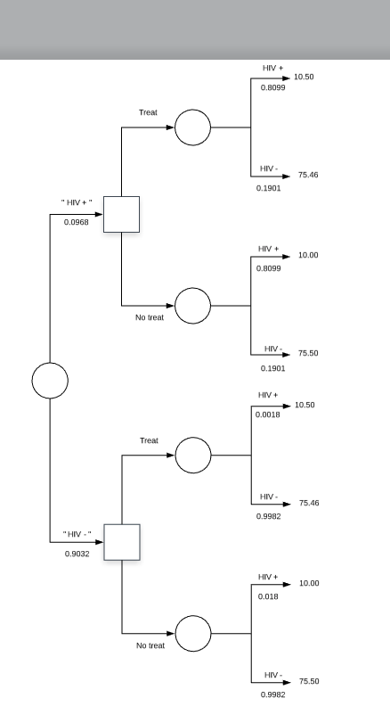 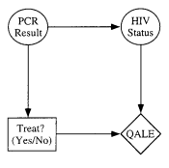

1. Same as the 1) but with the new b) above
2. Summary

Without the information of the HIV status, the calculation can only reply on the PCR results so that the expected unity should be based on the estimation value (“HIV+”/”HIV-”) instead of the true value (HIV+/HIV-).

$$EU\left[\text{"}\text{HIV+}\text{"}, T_{x}+\right]=P\left(HIV+ | \text{"}\text{HIV+}\text{"}\right)U\left[HIV+, T_{x}+\right]+P\left(HIV- | \text{"}\text{HIV+}\text{"}\right)U\left[HIV-, T_{x}+\right]=22.8489$$

$$EU\left[\text{"}\text{HIV+}\text{"}, T_{x}-\right]=P\left(HIV+ | \text{"}\text{HIV+}\text{"}\right)U\left[HIV+, T_{x}-\right]+P\left(HIV- | \text{"}\text{HIV+}\text{"}\right)U\left[HIV-, T_{x}-\right]=22.4516$$

$$EU\left[\text{"}\text{HIV}-\text{"}, T_{x}+\right]=P\left(HIV+ | \text{"}\text{HIV}-\text{"}\right)U\left[HIV+, T_{x}+\right]+P\left(HIV- | \text{"}\text{HIV}-\text{"}\right)U\left[HIV-, T_{x}+\right]=75.3431$$

$$EU\left[\text{"}\text{HIV}-\text{"}, T_{x}-\right]=P\left(HIV+ | \text{"}\text{HIV}-\text{"}\right)U\left[HIV+, T_{x}-\right]+P\left(HIV- | \text{"}\text{HIV}-\text{"}\right)U\left[HIV-, T_{x}-\right]=75.3821$$

$$EU\left[T_{x}+\right]=22.8489+75.3431=98.192$$

$$EU\left[T_{x}-\right]=22.4516+75.3821=97.8337$$

1. Following the calculation of 2), we can obtain the expected unity of the PCR based on the probability of estimation and the expected unity with this estimation.

$$EU\left[\text{PCR}\right]=P(\text{"}\text{HIV+}\text{"})EU\left[\text{"}\text{HIV+}\text{"}, T_{x}+\right]+P(\text{"}\text{HIV}-\text{"})EU\left[\text{"}\text{HIV}-\text{"}, T_{x}-\right]=70.2969$$